COMPUTER ARCHITECTURE

LAB #1, 17:05

Nykonchuk Illia, 245693

**Analyzing methods**

All circuits were analyzed by reading 74194 chip documentation, logic diagram and by checking the behavior of circuits entering various combinations of values into A B C D inputs with different operating modes (“S0” and “S1”).

**Circuits**

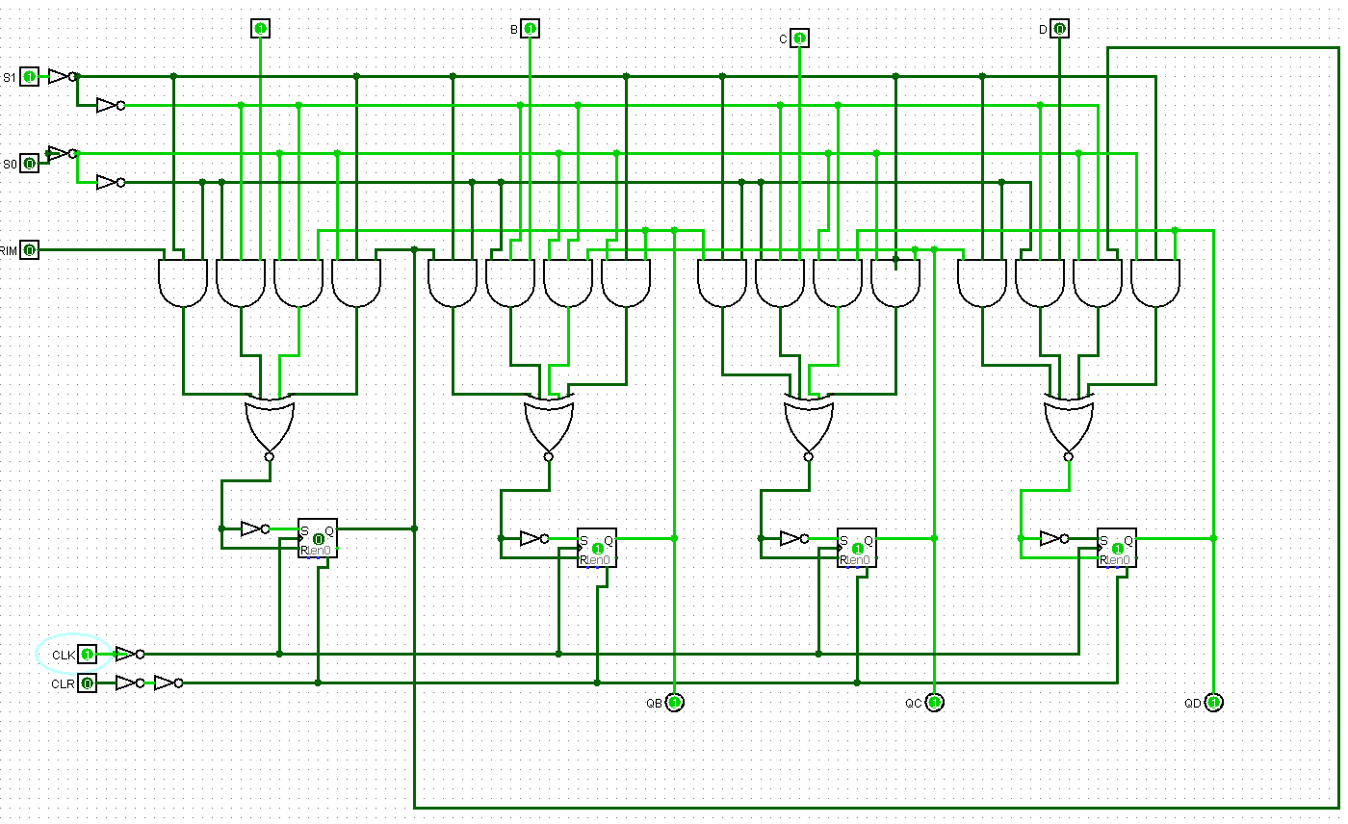

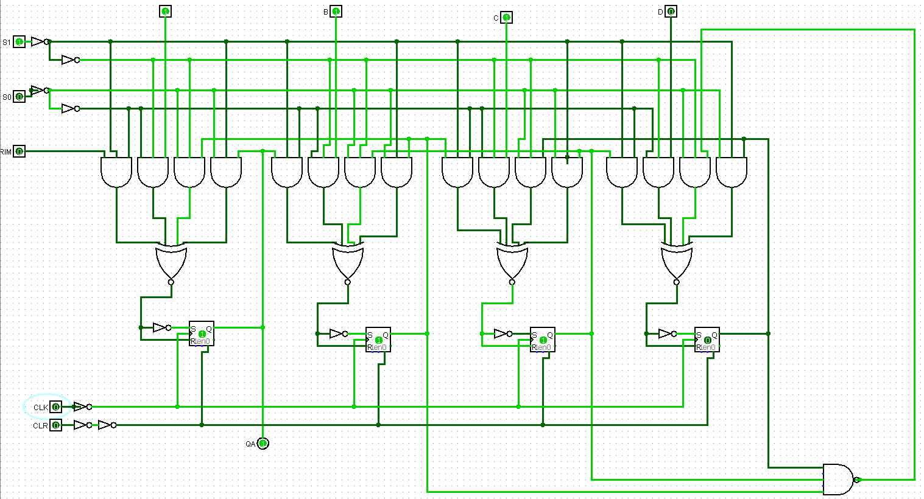

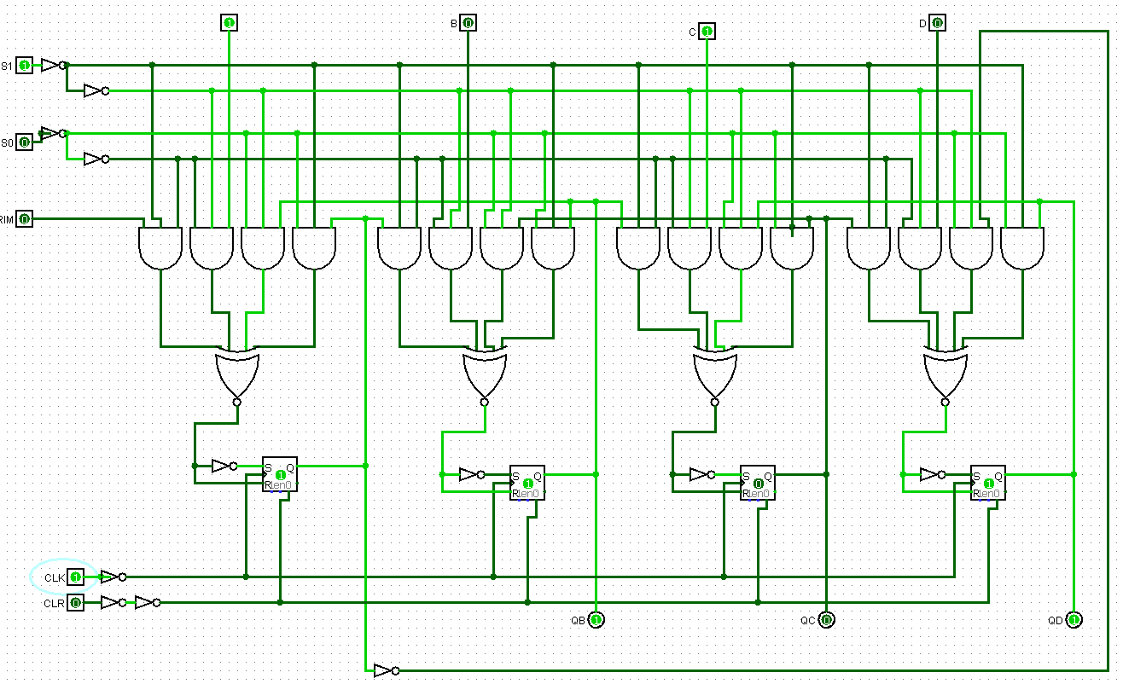

**Operations Description**

1. 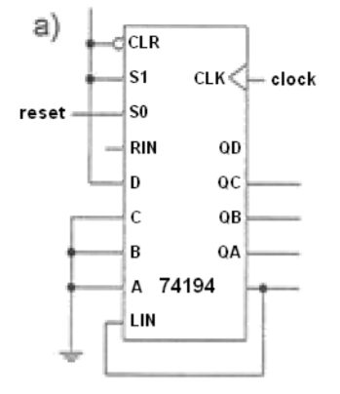The circuit performs a left shift register operation. Inputs “A”, “B” and “C” are connected to GND, therefore their values are always 0. LIN is responsible for saving missing bit while shifting, so it saves value from QA and moves it to QD
2. 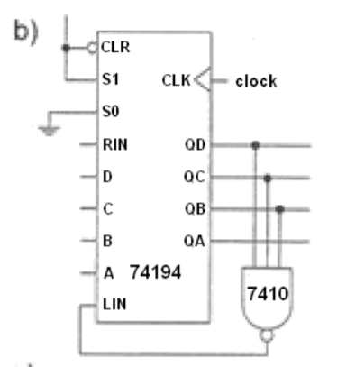 In the following circuit three outputs are connected to 7410 chip which permorms NAND operation and it is connected to LIN. So that means, that if we have “true” values in QB QC QD, NAND becomes “false” and “0” from QA moves to QD. In other cases, “0” just shifts to the left

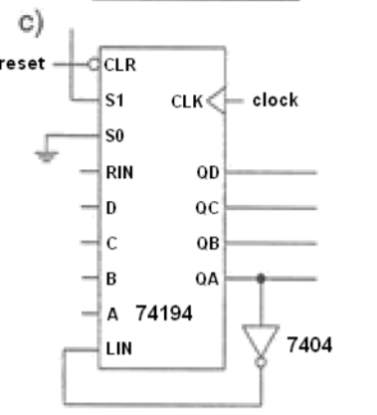

1. Following circuit works as a first circuit (shift operation to the left), but QD takes QA’s opposite value